***Uninterruptible Power Supply***

* An Uninterruptible Power Supply (UPS) is defined as a piece of electrical equipment which can be used as an immediate power source to the connected load when there is any failure in the main input power source.
* When compared to other immediate power supply system, UPS have the advantage of immediate protection against the input power interruptions.
* It has very short on-battery run time; however this time is enough to safely shut down the connected apparatus (computers, telecommunication equipment etc) or to switch on a standby power source.
* UPS can be used as a protective device for some hardware which can cause serious damage or loss with a sudden power disruption.

## Major Roles of UPS

* When there is any failure in main power source, the UPS will supply the power for a short time. This is the prime role of UPS.
* In addition to that, it can also able to correct some general power problems related to utility services in varying degrees. The problems that can be corrected are [voltage](https://www.electrical4u.com/voltage-or-electric-potential-difference/) spike (sustained over voltage), Noise, Quick reduction in input voltage, Harmonic distortion and the instability of frequency in mains.

## Types of UPS

### Off-line UPS

* This UPS is also called as Standby UPS system which can give only the most basic features.
* The primary source is the filtered AC mains (shown in solid path in

Figure 1)

* When the power breakage occurs, the transfer switch will select the backup source (shown in dashed path in figure 1).
* Thus we can clearly see that the stand by system will start working only when there is any failure in mains.
* In this system, the AC voltage is first rectified and stored in the storage battery connected to the rectifier.
* When power breakage occurs, this DC voltage is converted to AC voltage by means of a [power inverter](https://www.electrical4u.com/power-inverter/), and is transferred to the load connected to it.
* This is the least expensive UPS system and it provides surge protection in addition to back up.
* The transfer time can be about 25 milliseconds which can be related to the time taken by the UPS system to detect the utility [voltage](https://www.electrical4u.com/voltage-or-electric-potential-difference/) that is lost.
* The block diagram is shown below.

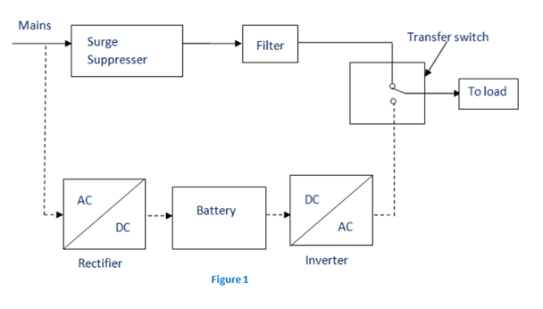

### On-line UPS

* In this **type of UPS**, double conversion method is used. Here, first the AC input is converted into DC by rectifying process for storing it in the rechargeable battery.
* This DC is converted into AC by the process of inversion and given to the load or equipment which it is connected (figure 2). This type of UPS is used where electrical isolation is mandatory.
* This system is a bit more costly due to the design of constantly running converters and cooling systems.
* Here, the rectifier which is powered with the normal AC [current](https://www.electrical4u.com/electric-current-and-theory-of-electricity/) is directly driving the inverter.
* Hence it is also known as Double conversion UPS. The block diagram is shown below.

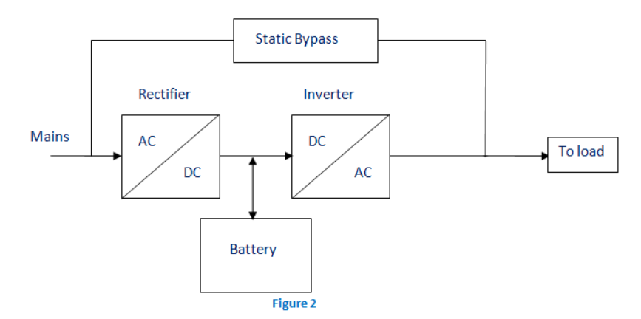

* When there is any power failure, the rectifier have no role in the circuit and the steady power stored in the [batteries](https://www.electrical4u.com/battery-working-principle-of-batteries/) which is connected to the inverter is given to the load by means of transfer switch.
* Once the power is restored, the rectifier begins to charge the batteries. To prevent the batteries from overheating due to the high power rectifier, the charging current is limited.
* During a main power breakdown, this UPS system operates with zero transfer time. The reason is that the backup source acts as a primary source and not the main AC input.
* But the presence of inrush current and large load step current can result in a transfer time of about 4-6 milliseconds in this system.

### Line Interactive UPS

For small business and departmental servers and webs, line interactive UPS is used. This is more or less same as that of off-line UPS. The difference is the addition of tap changing [transformer](https://www.electrical4u.com/what-is-transformer-definition-working-principle-of-transformer/). [Voltage regulation](https://www.electrical4u.com/voltage-regulation-of-transformer/) is done by this tap-changing transformer by changing the tap depending on input [voltage](https://www.electrical4u.com/voltage-or-electric-potential-difference/). Additional filtering is provided in this UPS result in lower transient loss. The block diagram is shown below.

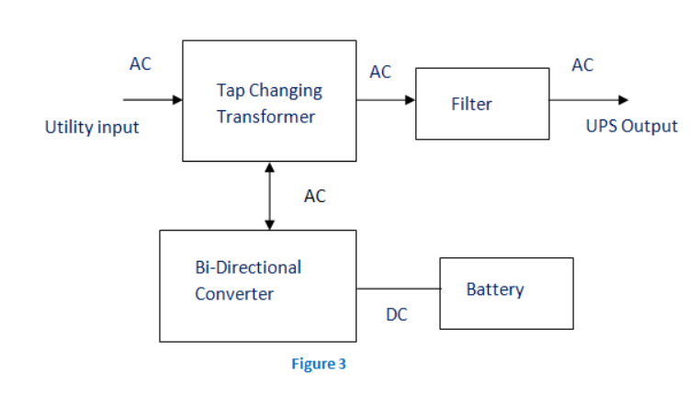

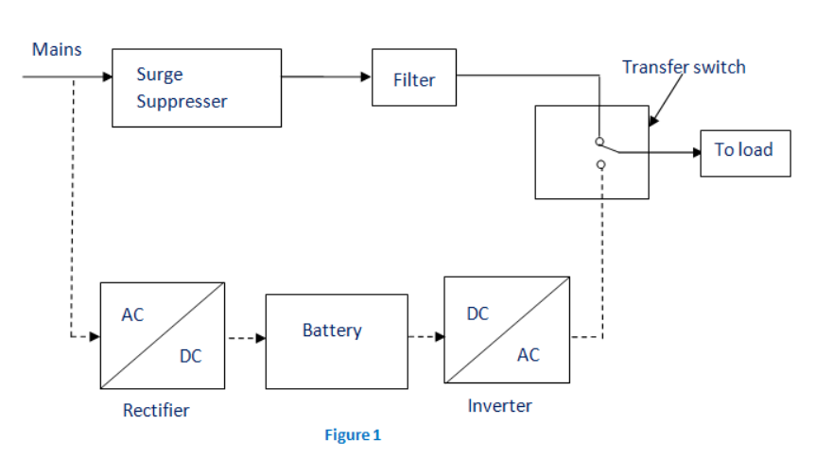

## UPS Applications

**Applications of a UPS** include:

* Data Centers
* Industries
* Telecommunications
* Hospitals
* Banks and insurance
* Some special projects (events)

***Power line consideration***

Plan the location of your Powerline devices:

**1.** Connect Powerline devices to electrical outlets that are not controlled by a wall switch to avoid accidentally turning off power to the device.

**2.** Do not connect the Powerline devices to an extension cord, surge protec-tor, or power strip as this might prevent it from working correctly, or nega-tively impact network performance.

**3.** Avoid using the Powerline devices in an electrical outlet that is located near to an appliance that uses a lot of power such as, a washing machine or tumble-dryer, or a refrigerator. This may prevent the adapter from working correctly, or negatively impact network performance.

**4**. Verify that your Powerline devices are electrically rated to operate within the power available within your location.

**5.** To help prevent against electrical shock, be sure to plug the power cables into properly grounded electrical outlets.

***Need of earthing***

Why is an Earthing Necessary?

Earthing is an important component of [electrical systems](https://en.wikipedia.org/wiki/Electric_power_system) because of the following reasons:

* It keeps people safe by preventing electric shocks
* It prevents damage to electrical appliances and devices by preventing excessive current from running through the circuit
* It prevents the risk of fire that could otherwise be caused by current leakage

Advantages of earthing

From a technical perspective, earthing has some excellent advantages, resulting it in becoming a mainstream practice in the electrical industry.

1. **Overload Protection** – In scenarios where excessive power surge occurs, a grounded system helps immensely. This simple form of surge protection can instantly save your electrical appliances and devices from getting fried by excessive electrical power, saving your data as well as equipment.
2. **Voltage Stabilization** – When it comes to calculating the right amount of power to be distributed between voltage sources, the earth provides that universal standard point of reference. Earthing takes the guesswork out of voltage stabilization, helping to ensure that no circuits overload or blow up.
3. **Damage, Injury & Death Prevention** – Blown fuses or a tripped circuit breaker are far more welcome than electrical fires or shocks, which can pose serious safety hazards to people and property. Essentially, grounding protects against equipment, property and data loss, as well as injuries and fatalities!

## *Factors Affecting PC-Operation*

PC is a machine with electrical and electronic circuits as well as electromechanical assemblies. For reliable operation and long life of PC, must consider various environmental factors.

The following factors affect the normal working of PC. These factors should be kept within the specified limits or tey to avoid these factor near PC for trouble-free operation.

**1> Temprature [10° C - 45° C]**

**Affects :**

* Life of IC's and other components.
* Encounter excessive chip creep.
* Signal traces on circuit board can crack and separate.
* Solder joints can break.
* Contacts in the system can undergo accelerated corrosion.
* Solid-state components such as chips can be damaged.
* Temperature generates intermittent problems in electronic circuits
* Early failure of electronic components.

**Avoiding Temperature :**

* Install an adequate fan in the power supply or system.
* Add an auxiliary fan.
* Run PC's only in safe temperature range.
* Install Air Conditioner in computer room.
* Avoid direct sunbeam in computer room.
* Use adequate space for computers.

**2> Humidity [60° Relative humidity]**

**Affects** :

* Causes corrosion in the contact region, which in turn causes contact problems in the different components.
* High humidity in low temperature will cause the surface oxidation effect on metal parts, such as electrical contacts & breakdown of insulation material in a power supplies & monitor.
* Low humidity, high temperature and dry weather may create problems with static electricity.
* May also generate sticky layer of dust on ICs and components, avoid heat dissipation.
* May fails ICs and component.

**Avoiding Humidity Problems :**

* Use dehumidifier.
* Install Air Conditioner in computer room.

**3> Dust :**

**Affects :**

* As dust buids up, entire board can become coated with fine insulating shealth. This avoids heat dissipation and damages ICs.
* Reduces life of chips and various components.
* It damages Magnetic tape storage of a computer. And causes head crash in Hard Disk.
* Dust on read/write head crashes disk surface.
* Keyboard may get affected with dust and dirt. It jams the keys and may cause improper functioning of keyboard.

**Avoiding Dust :**

* The computer room must be cleaned regularly.
* Clean the computer with dust free cloth.
* Use vacuum to remove dust from the keyboard and system board.
* Wndows in the computer room must be enclosed with curtains to prevent entry of dust.
* Smoking in the computer room must be prohibited.
* Use covers on different parts of computer such as monitor, system unit, keyboards.
* Use Air Conditioner for computer room.

**4> Magnetic Field Effect :**

**Affects :**

* Data storage on magnetic storage devices may get affected or corrupted.
* May disturb electron beams of CRT monitor, causinf improper deflection.
* Can cause permanent loss of data on hard disk.

**Avoiding Magnetic Field :**

* Keep PC away from the Television.
* Keep PC away from the Speaker.
* Do not keep any permanent magnet or electromagnet near PC.
* Do not keep any recording machine near to PC

# ***Factors affecting computer performance***

**1) The speed of the CPU**  
The speed of the CPU is also known as the clock speed of the CPU. The clock speed of the CPU is the frequency of which the processor executes instructions or the frequency by which data is processed by the CPU. It is measured in millions of cycles per second or megahertz (MHz). If the Clock speed of the CPU is fast then definitely the performance of the computer will be affected positively, in other words the computer will carry out processing functions at a faster pace.  
  
**2) The size of the RAM (Random Access Memory)**The RAM is referred to as the active part of the computer. This is because the RAM has the capability of storing data that the computer is currently using, because of the fact that it is fast to retrieve data stored in the RAM. With the definition above, a large RAM size will mean a faster computer performance and a smaller RAM size will result to slower computer performance.  
  
**3) The speed of the hard disk**The hard disk speed is defined as the rate at which material and content can be read and written on it. The hard disk speed of different hard disks is not consistent because they vary by manufacturer, drive type and the use of the hard disk. It therefore means that the higher the speed of the hard disk the

faster the performance of the computer and vice versa.  
  
**4) Hard disk space**  
The bigger the space on the hard disk will result to faster performance of the computer. The smaller the space on the hard disk will result in a slower performance of the computer. The hard disk is filled with data this will use most of the memory leaving less memory for the operations of the processor.  
  
**5) Multiple applications running on the computer**  
Multi-tasking tends to slow down the performance of the computer because memory is used to support more than one applications compared to when one application has all the memory to itself. This means that the more applications that are running the slower the computer will perform. Likewise if less or one application is running the performance of the computer will be faster.  
  
**6) Type of graphic card**When it comes to quality of pictures and animations graphic cards are the main factors. So if a machine processes many graphics and it has a weak graphic card it will perform slower. This means that the more powerful the graphic card is the faster the performance of the computer.  
  
**7) Defragmenting files**Files that are broken or it takes long to read them will mean that the computer will have to defragment them first. This will slow down the performance of the computer.